Assignment 3: Strategic Alignment at N108 Bank: Integrating Business, Information, and Systems Architecture

INF2177H S LEC0101 - Group 6
Instructor: Dr. Safwat Hassan
Word Count: 3214
Date: April 6, 2026
Name | Student ID
Ariel Xiao | 1004761180
Catherine Yuan | 1003089230
Norah Zhou | 1011745603
Parris McKenley | 996436557
Yixuan Zhang | 1010790280

Executive Summary
N108 Bank currently faces two main sources of pressure. The first is integrating the recently acquired Discover network, and the other is driving digital transformation, moving the organization towards enhanced automation. To address these challenges, this report proposes an aligned enterprise information architecture and systems architecture to address both challenges.

This analysis focuses on two main scenarios. The first is post-merger integration, where the lack of standardized data creates information silos. The second is digital transformation, where traditional manual decision-making methods become insufficient. To address these challenges, the report proposes corresponding solutions. For information architecture, a standardized enterprise data model containing ten core entities was designed, eight company-wide information processing flows were created, and a governance framework was established. Regarding system architecture, an AI-integration platform was built for the first scenario to connect various legacy systems, and for the second scenario, an AI-enhanced customer relationship management system and an intelligent credit scoring system were used to automate decision-making processes.

These two architectures can be aligned through three mechanisms. First, being the unified data semantic foundation for all systems; second, data attributes create direct dependencies between the information and application layers, and governance positions provide oversight for the outputs. This analysis also consists of four steps. Starting from analyzing the future business scenarios, then designing the information architecture and application system architecture, and finally using a standardized enterprise data model to check alignments.

Table of Contents

Introduction 4
Section 1: Scenarios for Business and Organizational Evolution 4
1.1 Context 4
1.2 Scenario 1: Post-Merger Integration 4
1.2.1 Challenge 5
1.2.2 Triggering Factors 5
1.2.3 Impact 5
1.2.4 IT implications and Solution 5
1.3 Scenario 2: Digital Transformation and Flatter Structure 5
1.3.1 Challenge 6
1.3.2 Triggering Factors 6
1.3.3 Impact 6
1.3.4 IT Implications and Solution 6
1.4 Summary 7
Section 2. N108 Bank: Enterprise Information Architecture Management 7
2.1 Overview and Justification 7
2.2 Major Information Entities and Key Relationships 7
2.3 Enterprise-Wide Information Processes 8
2.4 Near- and Medium-Term Architecture Needs 9
2.5 Information Governance 10
2.6 Data Layer Changes by Scenario 11
Section 3: Application Systems Architecture: Portfolio Design and Interoperability 13
Section 4: Strategic Alignment: Bridging Information and Systems Architectures 15
Section 5. Approach and Methodology 17
5.1 Choice of Frameworks, Modelling Techniques 17
Statement of Individual Contributions 18
References 19
Appendix: 21

List of Figures

Figure 1. Scenario 1: Post-Merger Integration and System Coordination (Enlarged views of key elements are included in the Appendix) 4
Figure 2. Scenario 2: Transition Toward a Data-driven and Agile Organization (Enlarged views of key elements are included in the Appendix) 6
Figure 3. Baseline Enterprise Information Model – N108 Bank · Current State · 10 entities 8
Figure 4. Scenario 1: Post-Merger Integration – Data Layer Changes 11
Figure 5. Scenario 2: Digital Transformation – Data Layer Changes 12
Figure 6. Original Layered Architecture 13
Figure 7. Scenario 1: Post-Merger Integration – Application Layer Changes 14
Figure 8. Scenario 2: Digital Transformation – Application Layer Changes 15
Figure 9. Research Roadmap 17

List of Tables

Table 1. N108 Bank Enterprise-Wide Information Processes 9
Table 2. N108 Bank Architecture Requirements – Two-Horizon Planning 10
Table 3. Proposed Information Governance Structure for N108 Bank 10

Introduction
This study builds on a previous analysis of N108 Bank's as-is state, which examined its business context, organizational architecture, information management practices, and systems landscape. This report focuses on the future-state architecture, proposing solutions in response to two possible organizational scenarios: post-merger integration and digital transformation. The analysis relies primarily on secondary research sources, including academic literature, industry analyses, technology case studies, and corporate publications, translated into structured visual models at each stage.

Section 1: Scenarios for Business and Organizational Evolution

1.1 Context
In the current fintech environment, N108 Bank is undergoing a transition toward more data-driven and intelligent operations (Verhoef et al., 2021).

In the next 2–3 years, these changes will affect both business and organizational architectures. They are driven by external pressures and internal restructuring, which are outside the control of the IT function but require architectural responses (Henderson & Venkatraman, 1993). This report proposes two agentic solution paths to address these changes.

1.2 Scenario 1: Post-Merger Integration
With increasing industry consolidation, N108 Bank is likely to expand through mergers or alliances (Porter’s Five Forces, 2025). This will create a more complex platform with multiple systems and business units that need to operate together.
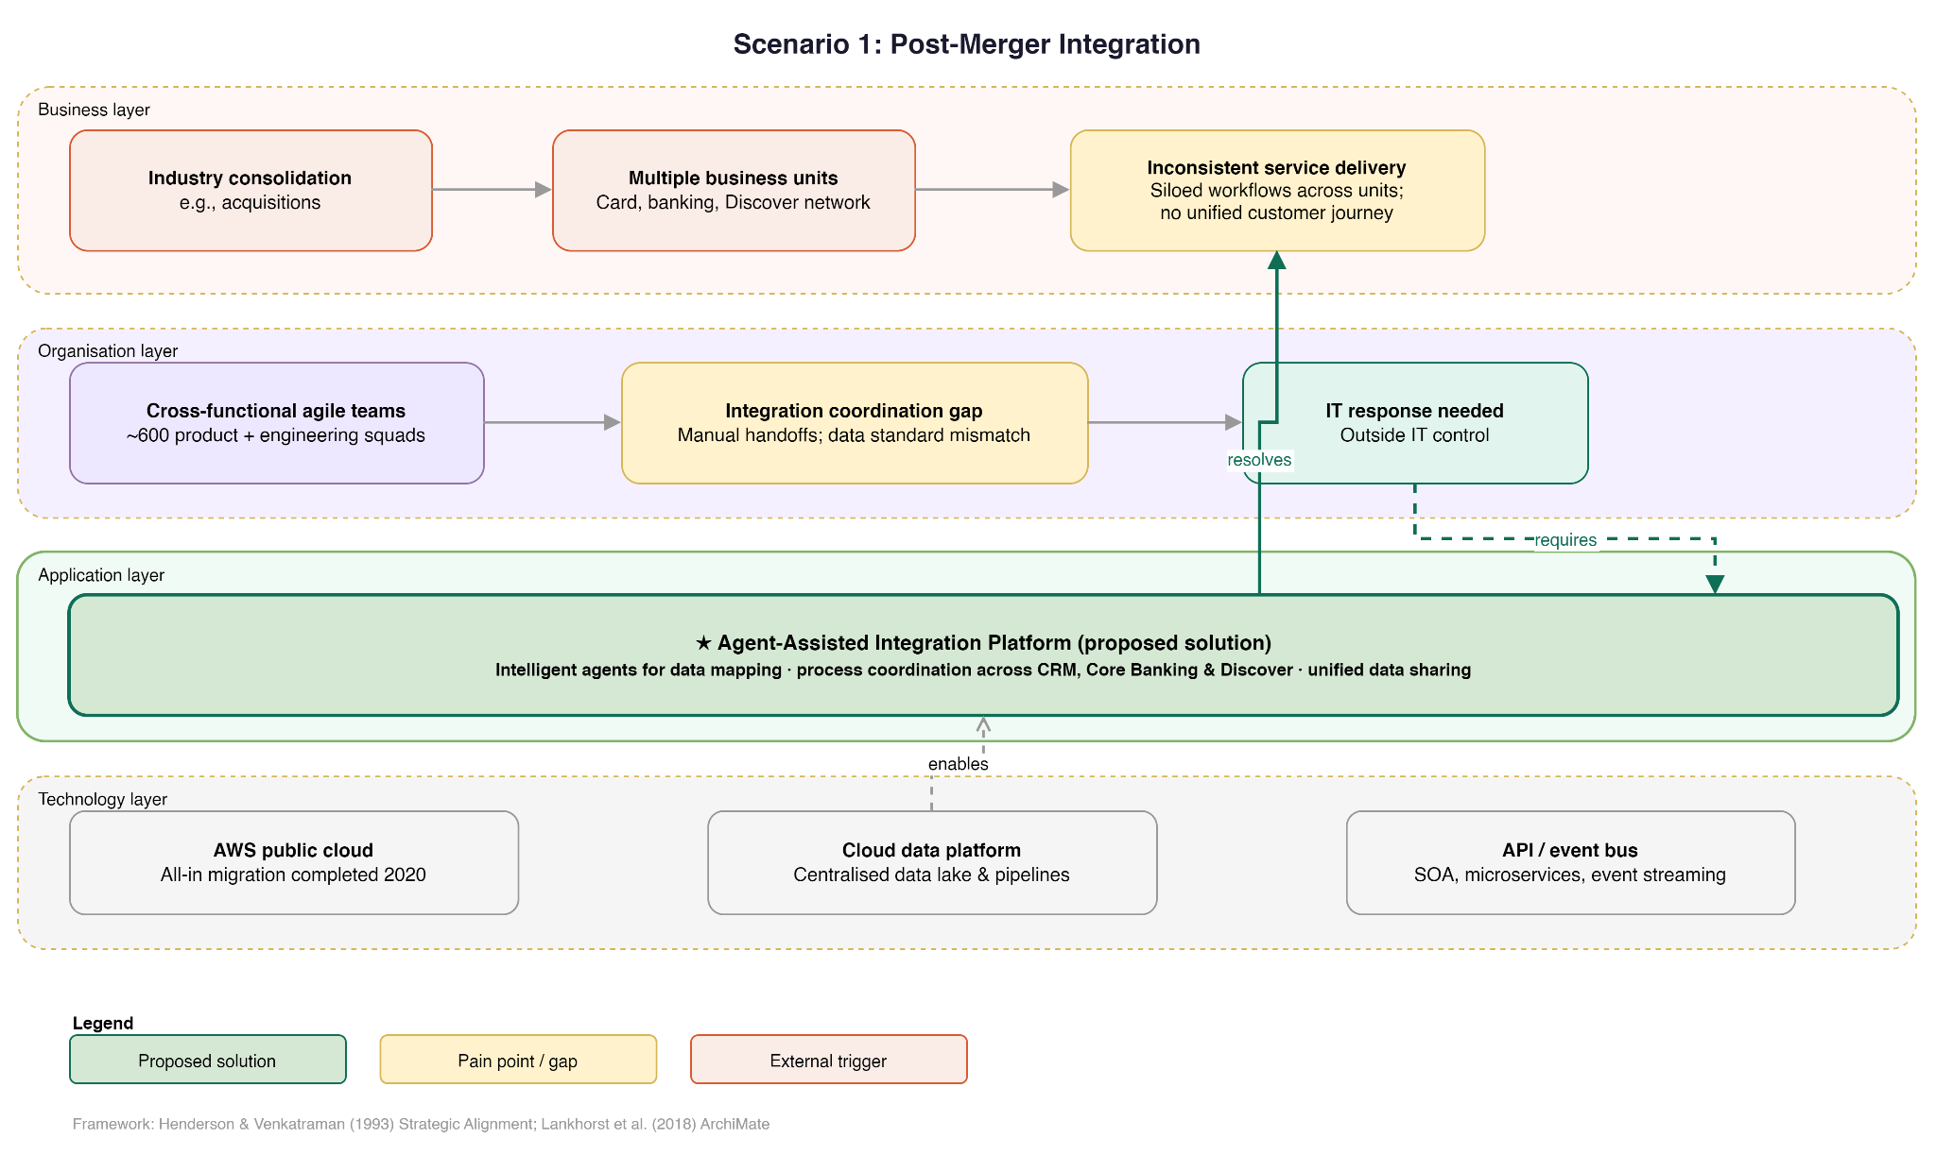

Figure 1. Scenario 1: Post-Merger Integration and System Coordination (Enlarged views of key elements are included in Appendix)

1.2.1 Challenge
Legacy systems and different data standards create integration issues, data silos, and inconsistent processes (Lankhorst et al., 2018). These differences make it difficult to align data formats, synchronize workflows, and ensure consistent service delivery across systems. Similar issues are common in financial institutions undergoing digital transformation (Murphy, 2014).

1.2.2 Triggering Factors
This scenario is driven by market competition and industry consolidation, as well as internal needs to expand capabilities and access more customer and transaction data. These factors are outside IT's control but directly affect how systems must evolve.

1.2.3 Impact
The organization must support more services and more complex customer journeys across systems. Coordination across business units becomes more important, especially for sharing customer data and maintaining consistent operations across channels.

1.2.4 IT implications and Solution
The IT function must improve system integration, data sharing, and process standardization. It also needs to reduce dependency on manual coordination between systems.

Proposed solution: Agent-assisted Integration Platform
This solution uses intelligent agents to support data mapping and process coordination across systems. It focuses on integrating CRM, core banking, and related systems to enable shared data, smoother workflows, and better coordination across business units.

1.3 Scenario 2: Digital Transformation and Flatter Structure
N108 Bank is also moving toward a flatter structure as part of its digital transformation (Verhoef et al., 2021). This shift reduces hierarchy and requires faster, more decentralized decision-making supported by real-time data.
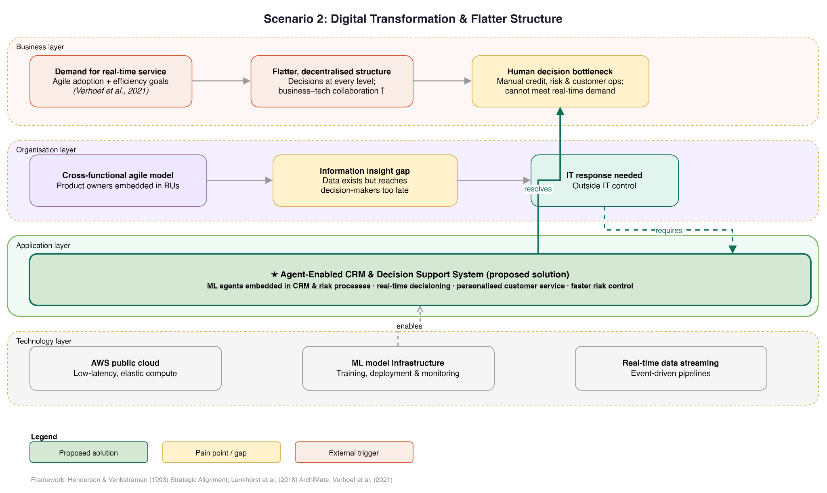

Figure 2. Scenario 2: Transition Toward a Data-driven and Agile Organization (Enlarged views of key elements are included in the Appendix)

1.3.1 Challenge
As data volume increases, human-based decision-making becomes a bottleneck. In credit, risk, and customer operations, manual processes cannot meet real-time needs (Westerman et al., 2014). This creates delays in decision-making and limits the organization’s ability to respond quickly to customer needs.

1.3.2 Triggering Factors
This scenario is driven by demand for real-time and personalized services, as well as technological advances. It is also influenced by agile practices and efficiency goals (Oreate AI, 2026), which require faster execution and reduced operational delays.

1.3.3 Impact
The organization becomes more data-driven and customer-focused. Decisions are made more frequently and at different levels of the organization. A flatter structure increases collaboration between business and technical teams and requires systems to support continuous interaction.

1.3.4 IT Implications and Solution
The IT function must support faster data processing, better system response, and increased automation. It also needs to provide timely insights to support decision-making.

Proposed solution: Agent-enabled CRM and Decision Support System
This solution introduces intelligent agents into CRM and risk processes to support real-time analysis and assist decisions. It improves efficiency, enables faster responses, and supports more personalized customer service and risk control.

1.4 Summary
Both scenarios are driven by external and internal factors. External pressures include competition, technology, and customer expectations. Internal factors include system complexity and organizational change.

These factors increase the need for the IT function to support integration, flexibility, and faster response (Henderson & Venkatraman, 1993). The two solutions offer different ways to address these challenges.

Section 2. N108 Bank: Enterprise Information Architecture Management

2.1 Overview and Justification
An enterprise information architecture (EIA) provides the conceptual foundation for how information is created, stored, shared, and governed across an organization (Zachman, 1987). For N108 Bank, facing post-merger integration pressures and digital transformation demands, a coherent EIA is a strategic imperative, as the organization risks persistent data silos, increased decision latency, and unreliable information for agentic systems.
The proposed EIA comprises three layers: a Canonical Enterprise Data Model (EDM); Enterprise-Wide Information Processes governing data flows; and an Information Governance Framework ensuring compliance, quality, and accountability. The Zachman Framework is selected as the primary architectural lens because it provides a structured, role-based view of information across all organizational levels, making it well-suited to an organization undergoing simultaneous integration and transformation (Zachman, 1987), complemented by Henderson & Venkatraman's Strategic Alignment Model (1993) to keep IT decisions anchored to business strategy. Enterprise data is treated as a strategic asset requiring active stewardship (Loshin, 2010). A canonical EDM is preferred over federated schemas to eliminate cross-system semantic inconsistency, a known risk where multiple legacy systems must interoperate without premature consolidation (Ross et al., 2006).

2.2 Major Information Entities and Key Relationships
Figure 2.1 presents the baseline enterprise information model, comprising ten entities: Customer, Account, Credit Card, Transaction, Payment, Merchant, Risk Profile, Fraud Alert, Employee/Analyst, and Regulatory Report, representing the minimum viable set for N108 Bank's operational scope (Loshin, 2010). Customer is the central hub, with all downstream processes tracing back to a unified customer record. Core relationships include: Customer–Account–Credit Card generating Transactions; Transaction anomalies triggering Fraud Alerts that update Risk Profiles; and Employees aggregating data for regulatory submissions to the Federal Reserve, OCC, and CFPB.

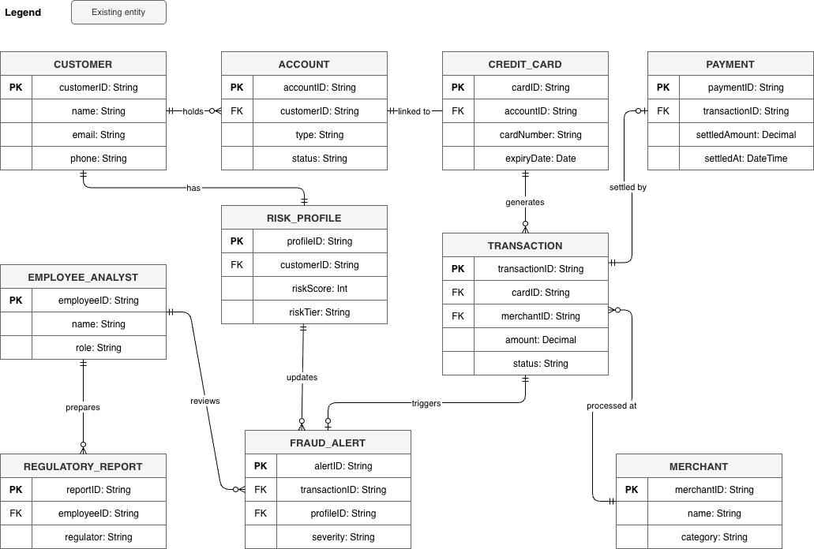

Figure 3. Baseline Enterprise Information Model – N108 Bank · Current State · 10 entities

2.3 Enterprise-Wide Information Processes
Table 2.1 summarizes the eight enterprise-wide information processes: Customer Onboarding (KYC/AML screening), Credit Decisioning (automated via Agent-enabled CRM), Transaction Processing (real-time authorization), Fraud Detection & Alert Management, Regulatory Reporting, Data Integration & Synchronization, Analytics & Reporting, and Data Retention & Disposal. These eight processes were selected because they collectively map N108 Bank's core value chain from customer acquisition through regulatory compliance, ensuring full lifecycle coverage without duplicating processes that belong to the systems architecture layer (DAMA International, 2017).

Table 1. N108 Bank Enterprise-Wide Information Processes
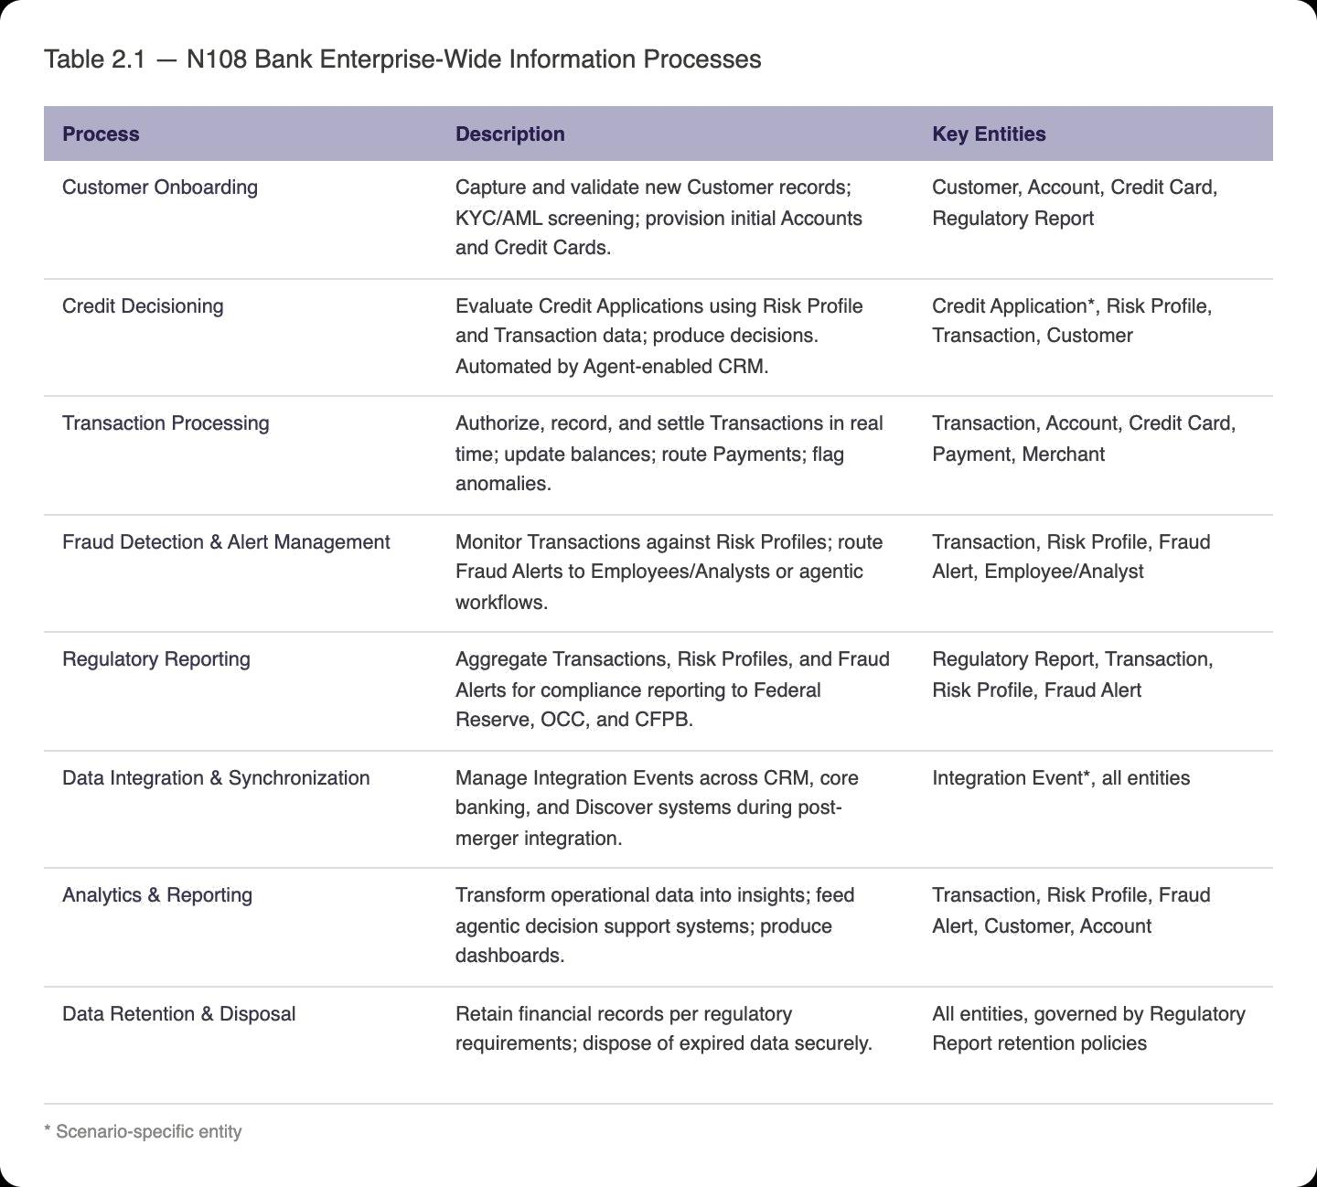

2.4 Near- and Medium-Term Architecture Needs
Table 2.2 outlines architecture requirements across a two-horizon framework, adopted because post-merger integration cannot wait for long-term transformation to be fully designed (Ross et al., 2006). Near-term priorities (0–2 years) include Integration Event logging, unified Customer master records, and automated Regulatory Reports. Medium-term priorities (2–5 years) include real-time synchronization, predictive customer profiling, and transition to a data lakehouse architecture (Armbrust et al., 2021).

Table 2. N108 Bank Architecture Requirements – Two-Horizon Planning
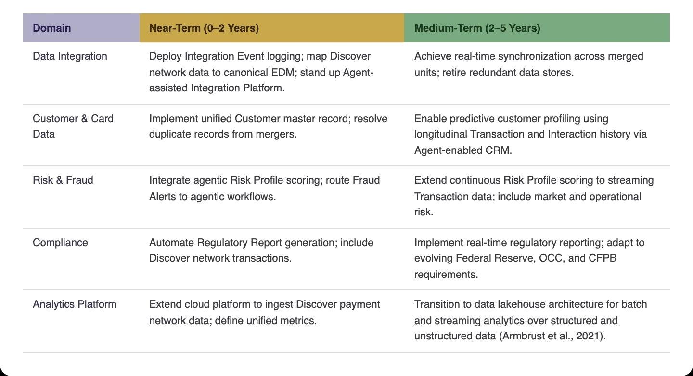

2.5 Information Governance
Table 2.3 presents the proposed governance structure. A new CDO sets enterprise data strategy, addressing a governance gap that federated ownership alone cannot resolve. A new Model Risk & AI Governance function is introduced as a distinct role, rather than extending existing risk teams, because OCC guidance requires independent model validation for AI-driven decisioning (Barch, 2023). Existing roles are expanded to cover Discover network obligations, with governance cycles covering Data Standardization, Quality Monitoring, Model & AI Audit, and Architecture Review.

Table 3. Proposed Information Governance Structure for N108 Bank
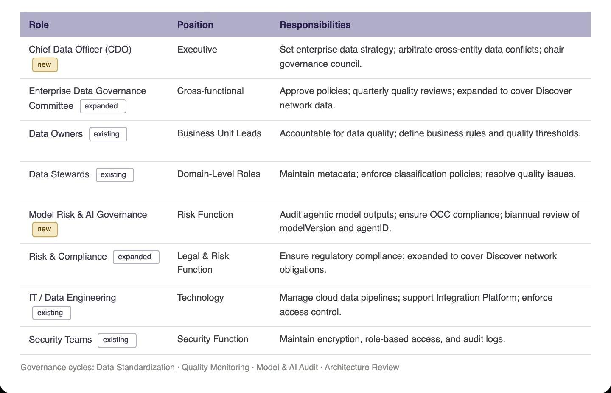

2.6 Data Layer Changes by Scenario
Scenario 1 – Post-Merger Integration
With increasing industry consolidation, N108 Bank is likely to expand through mergers or alliances. The post-merger scenario introduces multiple legacy systems that must exchange data reliably without premature consolidation. A new Integration Event entity (eventID, sourceSystem, targetSystem, payloadSchemaVersion, status, timestamp) captures every cross-system data exchange, providing a full audit trail across CRM, Core Banking, and new infrastructure, mediated by an Agent-assisted Integration Platform. Integration Event is chosen as a system-agnostic audit log, decoupling integration tracking from any single source system (Lankhorst et al., 2018). Data Owners are assigned stewardship of Integration Event records, with unresolved conflicts escalated to the Governance Committee.

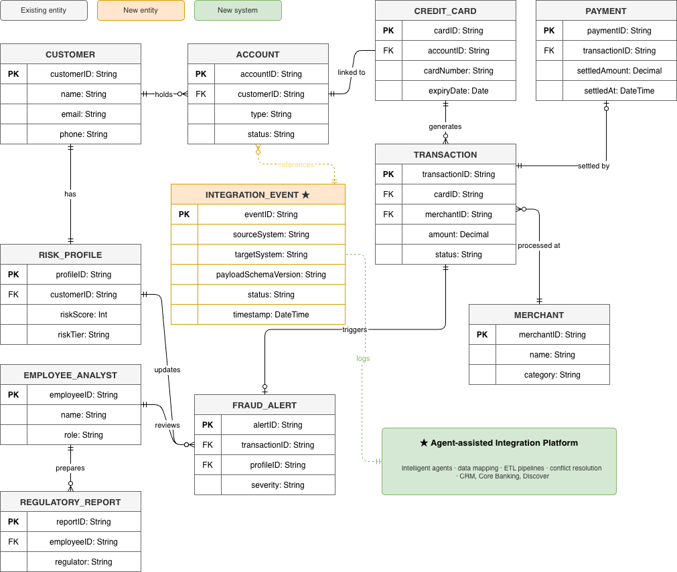

Figure 4. Scenario 1: Post-Merger Integration – Data Layer Changes

Scenario 2 – Digital Transformation and Flatter Organization
As N108 Bank transitions toward a more automated operating model, agentic systems take on credit decisioning, fraud resolution, and risk scoring. A new Credit Application entity (applicationID, requestedAmount, status, decisioningRationale) supports automated decisioning via the Agent-enabled CRM. Risk Profile gains modelVersion and agentID attributes for regulatory accountability; Fraud Alert gains a resolvedBy attribute to distinguish human from agentic resolution. The Model Risk & AI Governance function conducts biannual audits of all agentic attributes.

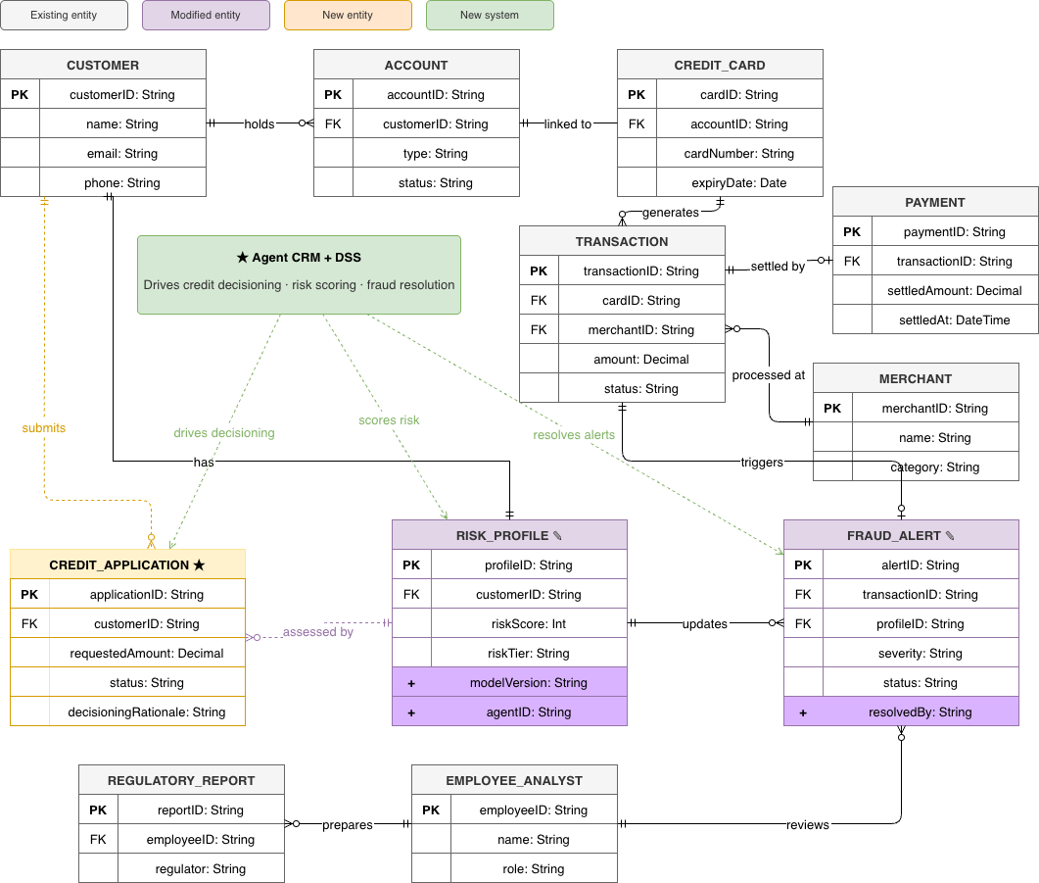

Figure 5. Scenario 2: Digital Transformation – Data Layer Changes

Section 3: Application Systems Architecture: Portfolio Design and Interoperability

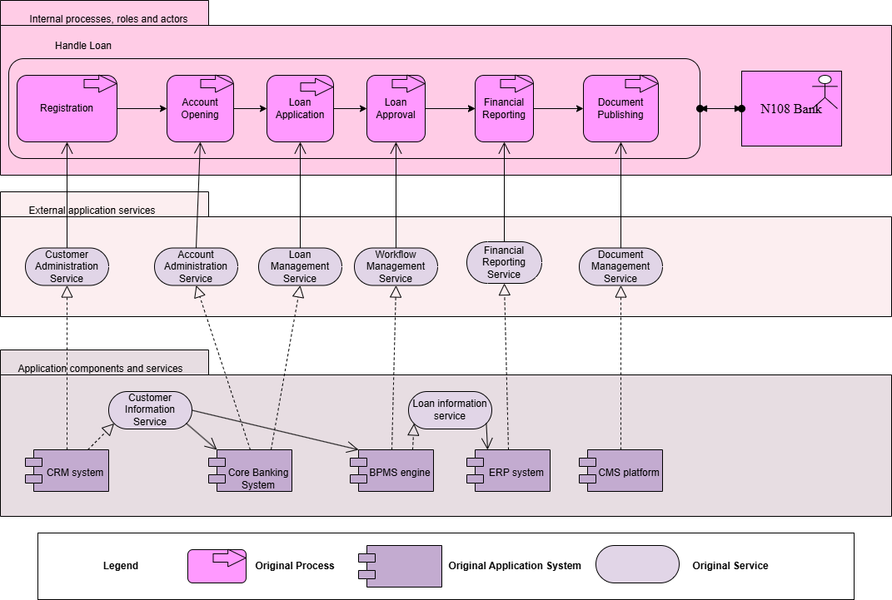

Figure 6. Original Layered Architecture

N108 Bank operates as a digital-first financial institution whose competitive strategy relies heavily on advanced application systems. Including Customer Relationship Management (CRM), Enterprise Resource Planning (ERP), Business Process Management Systems (BPMS), Content Management System (CMS), and core banking applications. These systems support customer services, internal operations, and decision-making. Together, they enable efficient business operations.

The CRM system manages customer data and interactions, it stores customer data, and supports manual decisions by providing essential customer data to other systems, such as core banking and BPMS (Buttle & Maklan, 2019). However, this interaction is not efficient, as the CRM system must frequently exchange data with multiple systems while primarily functioning as a data repository. It lacks advanced analytical capabilities and therefore does not generate meaningful insights or support automated decision-making.

Core banking systems act as the central transactional platform, handling account management and loan processing while exchanging data with CRM for customer information and with ERP for financial reporting.

The BPMS coordinates and automates key business processes, such as loan applications and approvals, by orchestrating workflows across multiple systems (Appian, 2023). It interacts with CRM for customer data, core banking for transaction processing, and CMS for document generation and communication.

The ERP system supports internal functions such as finance and reporting by collecting data from the core banking system. This enables accurate financial analysis and organizational planning (Monk & Wagner, 2013).

The CMS manages digital content and documents, supporting communication with customers and ensuring consistency across channels (Nadkarni & Gupta, 2022). It integrates with BPMS and core banking systems to generate and deliver documents related to customer transactions.

Overall, these systems are interconnected through a service-oriented approach, where each system exchanges data and services with others. This integration enables seamless business processes, efficient operations, and improved customer experience, while also allowing the architecture to evolve as new technologies are introduced.

However, from the system layered architecture (Figure), it can be observed that:

- The organization relies on multiple application components, including the Customer Relationship Management (CRM) system, core banking system, and the Business Process Management System (BPMS), which are connected through application services to support business processes such as customer onboarding and loan handling. However, these systems operate as separate components with different data structures and standards, leading to integration challenges, data silos, and inconsistencies across the architecture.
- In the loan processing workflow, from loan application to loan approval, the process still requires manual intervention for each application, which reduces overall efficiency. In addition, the Customer Relationship Management (CRM) system primarily functions as a data provider, requiring frequent data exchange with multiple systems. It lacks advanced analytical capabilities, limiting its ability to generate meaningful insights or support automated decision-making.

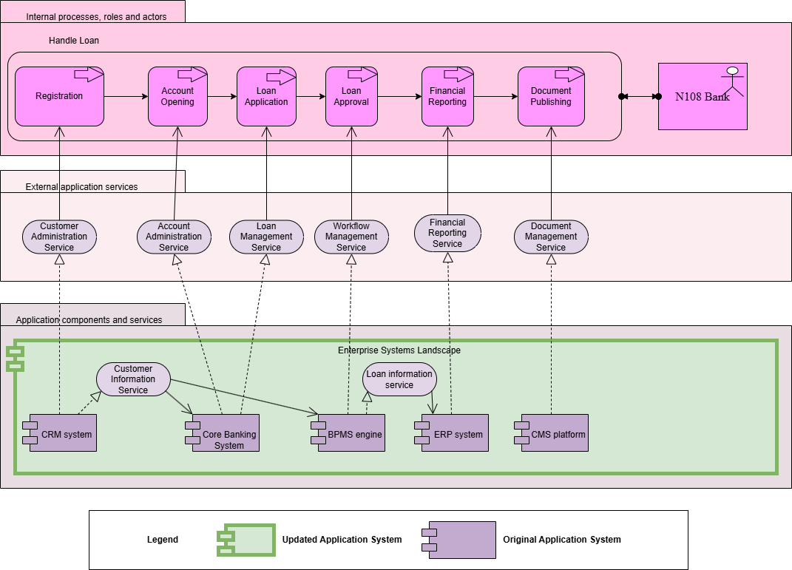

Figure 7. Scenario 1: Post-Merger Integration – Application Layer Changes

In the first scenario, an enterprise system landscape is designed to address integration challenges across existing applications (as shown in the green section of the figure). An agent-assisted integration platform is introduced to enable intelligent data mapping, transformation, and process coordination across core systems such as CRM and core banking (IBM, n.d.). This improves data consistency, streamlines workflows, and enhances cross-business coordination while reducing reliance on manual integration efforts and increasing operational efficiency.

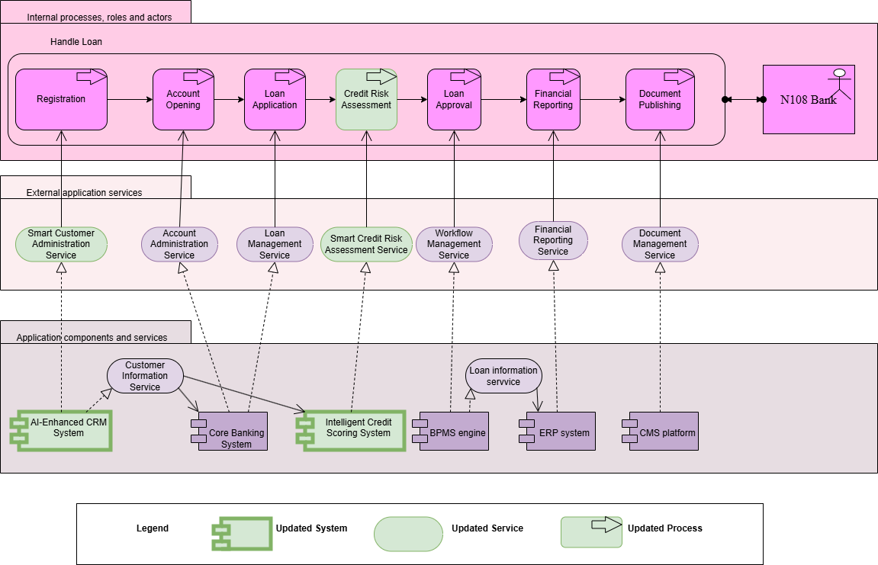

Figure 8. Scenario 2: Digital Transformation – Application Layer Changes

In the second scenario, compared to the original process, the CRM system is updated to an AI-Enhanced CRM system, which automates customer interaction, supports real-time decision-making, and provides personalized recommendations based on live data analysis (Salesforce, n.d.). Additionally, an Intelligent Credit Scoring System is introduced to improve the efficiency and accuracy of the risk assessment process. Instead of manual risk evaluation, an agentic system is used to automate credit risk assessment and improve decision efficiency (IBM, n.d.). (The updated parts are shown in the green section of Figure)

Section 4: Strategic Alignment: Bridging Information and Systems Architectures

The Enterprise Information Architecture (EIA) and system architecture designed for the N108 Bank are mutually supportive and closely aligned with the bank’s business strategy. The Strategic Alignment Model, proposed by Henderson and Venkatraman in 1993, provides the theoretical basis for this approach. This model emphasizes that alignment is not a one-off task but a continuous process for ensuring that every IT decision serves the core business requirements. For N108 Bank, this means that every architectural decision needs to be traceable back to the two scenarios mentioned in the previous part: one is post-merger integration, and the other is digital transformation to achieve higher levels of automation.

The most direct bridge between these two architectures is the standardized enterprise data model. As described in Section 2, the enterprise information architecture identifies ten main entities, including Customer, Account, Transaction, Risk Profile, and Fraud Alert, as the minimum viable set for N108 Bank’s operational scope (Loshin, 2010). These form the foundational data supporting N108 Bank’s daily operations. The system architecture described in Section 3 relies on this unified semantic foundation to function smoothly. Without a standardized data model to unify the data formats from the various systems acquired in the Discover acquisition, this integration platform lacks a stable reference standard to coordinate the data from all parties. A standardized data architecture is an essential prerequisite for a stable system (Ross, Weill & Robertson, 2006).

For Scenario 2, this alignment relies primarily on close collaboration in two areas. The first is the modification made to the enterprise information architecture at the data layer, and the second is the upgrade plan for the system architecture. Section 2 added some agentic attributes, such as adding a modelVersion and agentID to the Risk Profile, and resolvedBy on Fraud Alert. These fields are designed to provide compliance-level accountability for automated decision-making. They will be directly used by the AI-enhanced customer relationship management system and intelligent credit scoring system mentioned in Section 3, which are responsible for automatically assessing credit risk and handling customer interactions. This dependency ensures that the data produced by the agentic system in the application layer meets the governance requirements set by the information layer. Without this mechanism, AI systems could be deployed directly without a corresponding accountability system. DAMA International mentioned in 2017 that this is a relatively common failure in financial institutions.

The alignment at the governance level further strengthens the connection between these two architectures. Section 2 proposes adding a Chief Data Officer position and creating a separate functional department responsible for model risk and AI governance. This department is required to review agency attributes every six months to follow OCC guidance on independent model validation (Barch, 2023). From an organizational perspective, the tasks of these governance roles are two-way. On the one hand, they must ensure that the information quality standards defined in the enterprise information architecture are implemented; on the other hand, they must supervise the data output by various application systems in Section 3. For example, Section 2 introduces the Integration Event entity for Scenario 1, and according to the rules, the data owner is responsible for managing the audit records generated by the Agent-assisted Integration platform in Section 3. This cross-layered responsibility arrangement ensures the consistency of information processing flows and system outputs across different business units, while also meeting various compliance needs (Zachman, 1987).

Section 5. Approach and Methodology

5.1 Choice of Frameworks, Modelling Techniques
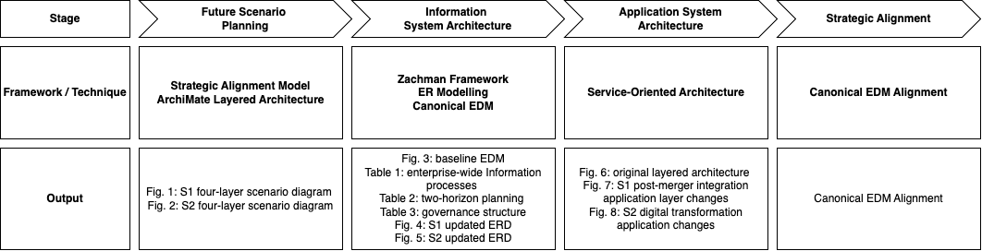

Figure 9. Research Roadmap

The analysis was conducted in four sequential stages, with frameworks selected at each stage to address the specific architectural layer under examination.
The study begins with scenario planning, applying Henderson and Venkatraman's Strategic Alignment Model (1993) to identify how external business pressures translate into specific IT responses. Each scenario was visualized using a four-layer Lankhorst's ArchiMate notation (Figures 1 and 2), mapping pain points and proposed solutions across each layer.
The second stage addresses the enterprise information architecture, where the Zachman Framework (Zachman, 1987) provided the study with a structured, role-based view of information across all organizational levels. A Canonical Enterprise Data Model was developed as a single, organization-wide definition of how data is structured and named. In ideal scenario, it will ensure that CRM, Core Banking, and Discover legacy systems all speak the same data language rather than maintaining their own incompatible formats. This was represented as a baseline entity-relationship diagram comprising ten core entities (Figure 3). Scenario-specific extensions were then shown in two separate data layer diagrams: the Integration Event entity was added for Scenario 1 (Figure 4), and the Credit Application entity was introduced for Scenario 2 (Figure 5).
The primary challenge at this stage was defining the right scope for the data model. Including too few entities risked omitting critical relationships, while including too many risked producing a model too abstract to be actionable. This was resolved by anchoring the model to a minimum viable set of ten entities covering N108 Bank's core operational scope, with extensions added only where the new business requirements clearly demanded them. Ross, Weill and Robertson's two-horizon planning framework (2006) was then applied and summarized in a structured table (Table 2), separating near-term stabilization priorities from medium-term transformation. Lastly, a governance structure table (Table 3) was also developed to formalize accountability roles, distinguishing new positions such as the CDO and Model Risk and AI Governance function from existing expanded roles.
The third stage examines the application systems architecture through a layered service-oriented architecture approach. The original architecture was first documented as a baseline layered diagram (Figure 6), which explains the as-is limitations such as fragmented systems, manual intervention required and a lack of analytical capability. Scenario-specific changes were then shown through two updated architecture diagrams (Figures 7 and 8), constructed as before-and-after comparisons to show precisely which systems are added or upgraded in each scenario.
The final stage addresses strategic alignment. This was addressed by using the Canonical Enterprise Data Model again as a concrete alignment bridge, tracing how specific entity attributes defined in the information architecture, such as modelVersion and agentID on Risk Profile and resolvedBy on Fraud Alert, are directly used by the AI-Enhanced CRM and Intelligent Credit Scoring System in the application layer (Figure 8). The governance structure proposed in the enterprise information architecture stage was similarly mapped onto the agentic outputs of the application systems stage, demonstrating cross-layer accountability. For example, Data Owners defined in Table 3 are responsible for managing the Integration Event audit records generated by the Agent-assisted Integration Platform in Figure 7.

Statement of Individual Contributions

All members discussed the different parts of the project ideas, and each person was assigned responsibility for writing one section.

Name | Contribution
Ariel Xiao | Section 3: Application Systems Architecture
Catherine Yuan | Executive Summary + Section 4: Strategic Alignment
Norah Zhou | Section 5: Choice of Frameworks & Modelling Techniques
Parris McKenley | Section 2: Information Architecture
Yixuan Zhang | Section 1: Scenarios for Business and Organizational Evolution

References

Appian. (2023). 6 benefits of BPM in the banking industry for improving CX. Retrieved from https://appian.com/bpm-basics/bpm-in-action/account-opening
Armbrust, M., Ghodsi, A., Xin, R., & Zaharia, M. (2021). Lakehouse: A new generation of open platforms that unify data warehousing and advanced analytics. Proceedings of CIDR 2021.
Barch, P. (2023). How to build a data governance strategy. Capital One Software. https://www.capitalone.com/software/blog/data-governance-strategy/
Buttle, F., & Maklan, S. (2019). Customer relationship management: Concepts and technologies (4th ed.). Routledge.
DAMA International. (2017). DAMA-DMBOK: Data management body of knowledge (2nd ed.). Technics Publications.
Henderson, J. C., & Venkatraman, N. (1993). Strategic alignment: Leveraging information technology for transforming organizations. IBM Systems Journal, 32(1), 4–16.
IBM. (n.d.). What is credit risk? https://www.ibm.com/topics/credit-risk
IBM. (n.d.). What is ERP integration? https://www.ibm.com/think/topics/erp-integration
Loshin, D. (2010). Master data management. Morgan Kaufmann.
Monk, E., & Wagner, B. (2013). Concepts in enterprise resource planning (4th ed.). Cengage Learning.
Nadkarni, S., & Gupta, B. (2022). Content management systems: Functions, benefits, and trends. Journal of Information Technology & Digital Services, 9(2), 45–62.
Ross, J. W., Weill, P., & Robertson, D. C. (2006). Enterprise architecture as strategy. Harvard Business School Press.
Russell, S., & Norvig, P. (2020). Artificial intelligence: A modern approach (4th ed.). Pearson.
Salesforce. (n.d.). What is AI CRM? https://www.salesforce.com/products/einstein/what-is-ai-crm/
Verhoef, P. C., Broekhuizen, T., Bart, Y., Bhattacharya, A., Dong, J. Q., Fabian, N., & Haenlein, M. (2021). Digital transformation: A multidisciplinary reflection and research agenda. Journal of Business Research, 122, 889–901.
Westerman, G., Bonnet, D., & McAfee, A. (2014). Leading digital: Turning technology into business transformation. Harvard Business Review Press.
Zachman, J. A. (1987). A framework for information systems architecture. IBM Systems Journal, 26(3), 276–292.

Appendix:
- Figure 1:
https://drive.google.com/file/d/1TzFP2JoHslMNyaOfOaCVg8XoqBs7GUwM/view?usp=sharing
- Figure 2：
https://drive.google.com/file/d/1KwDEZSXEvayAh8VFY5ittLoT1lQdvpPt/view?usp=sharing
- Figure 3: https://drive.google.com/file/d/1Be3ncJXsUadt9p3vcP8_sNxScDuJXHQh/view?usp=drive_link
- Figure 4: https://drive.google.com/file/d/1R538dK0Wr4_Sru2nSxC8RnpZlvKybSkJ/view?usp=drive_link
- Figure 5: https://drive.google.com/file/d/1H9qfUA9Z7HEP_OjRQ-9K22_KE6W7rcwp/view?usp=drive_link
- Figure 6:
https://drive.google.com/file/d/1rXPOIgBOPw5Pz5_lUPzI7Dng-HnWt1hI/view?usp=sharing
- Figure 7:
https://drive.google.com/file/d/1r-Mk-f9IsFgd0Pd1lV3Rsh2IpjKVkSl_/view?usp=sharing
- Figure 8:
https://drive.google.com/file/d/1TdtNmHzu2p0FyERocS5kwG6yebqfc3ll/view?usp=sharing
- Figure 9:
https://drive.google.com/file/d/1OC9tVHR-EsOCFAc7xo15N2S4bH_NJdv6/view?usp=drive_link

